WEB DESIGN TECHNICAL REPORT 2025–2026
Project: Lost and Found Management System
University of Rwanda
Student: 225063489
Year: 2026

Table of Contents
1. Introduction
2. System Analysis and Design
3. Implementation
4. Conclusion and Recommendations
Appendix

Chapter 1: Introduction

1.1 Historical Background
Lost items such as phones, wallets, IDs and bags are common in schools and public places. Manual reporting is slow and unreliable. This project provides a web-based platform to report, search and recover lost items.

1.2 Problem Statement
There is no centralized system for managing lost and found items, causing delays and low recovery rates mostly in universities and other public areas.

1.3 Objectives
• Register and authenticate users.
• Report lost and found items.
• Search for items.
• Provide an admin dashboard.
• Store data securely in a database.

1.4 Expected Outcomes
Faster reporting, improved item recovery, secure record keeping and easier communication.

1.5 Project Rationale
The system benefits students, staff and the public by replacing manual processes with an efficient digital solution.

Chapter 2: System Analysis and Design

2.1 Intended Users
Students, staff, visitors and administrators.

2.2 Intended Partners
Universities, schools, police stations and public institutions.

2.3 High-Level Architecture

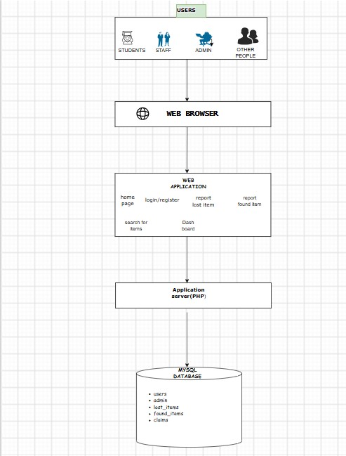

2.4 User Interface
Main pages: Home, Login, Register, Report Lost Item, Report Found Item, Search, Contact Us and Admin Dashboard.

2.5 Database Design
Main tables: Users, Lost_Items, Found_Items and Claims. Users submit reports while the administrator manages records.
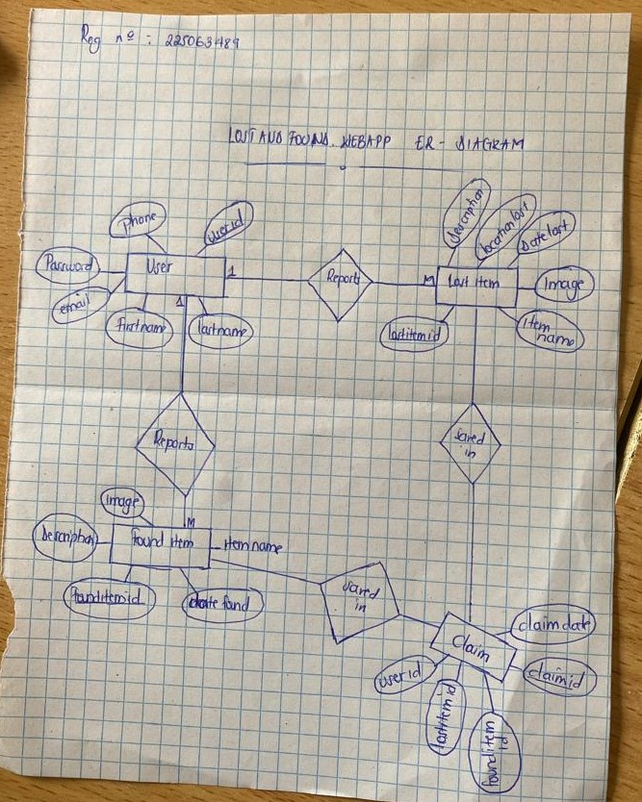

Chapter 3: Implementation
The system was developed using HTML, CSS, JavaScript, PHP and MySQL on XAMPP.
Home Page
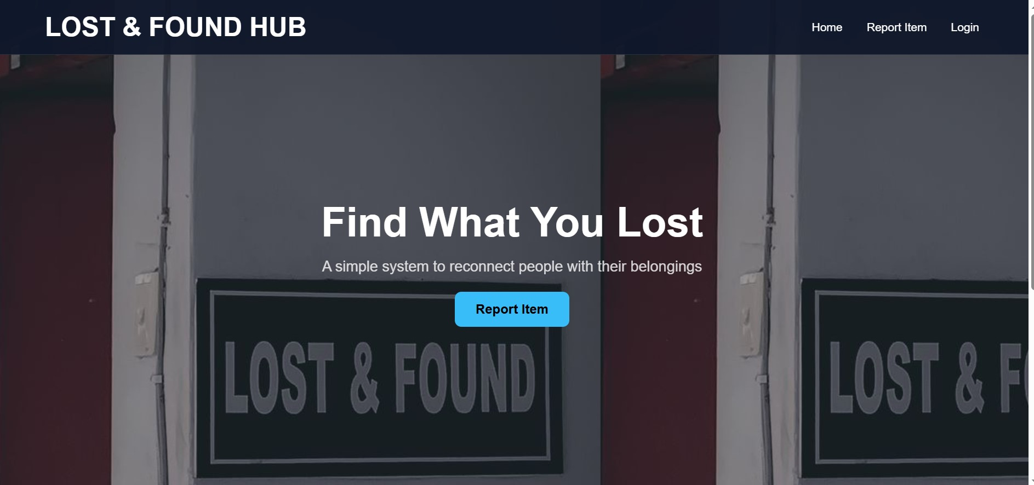
This is the page which navigates the whole webpage . A user can either report,login or register on the webpage
Login page

o
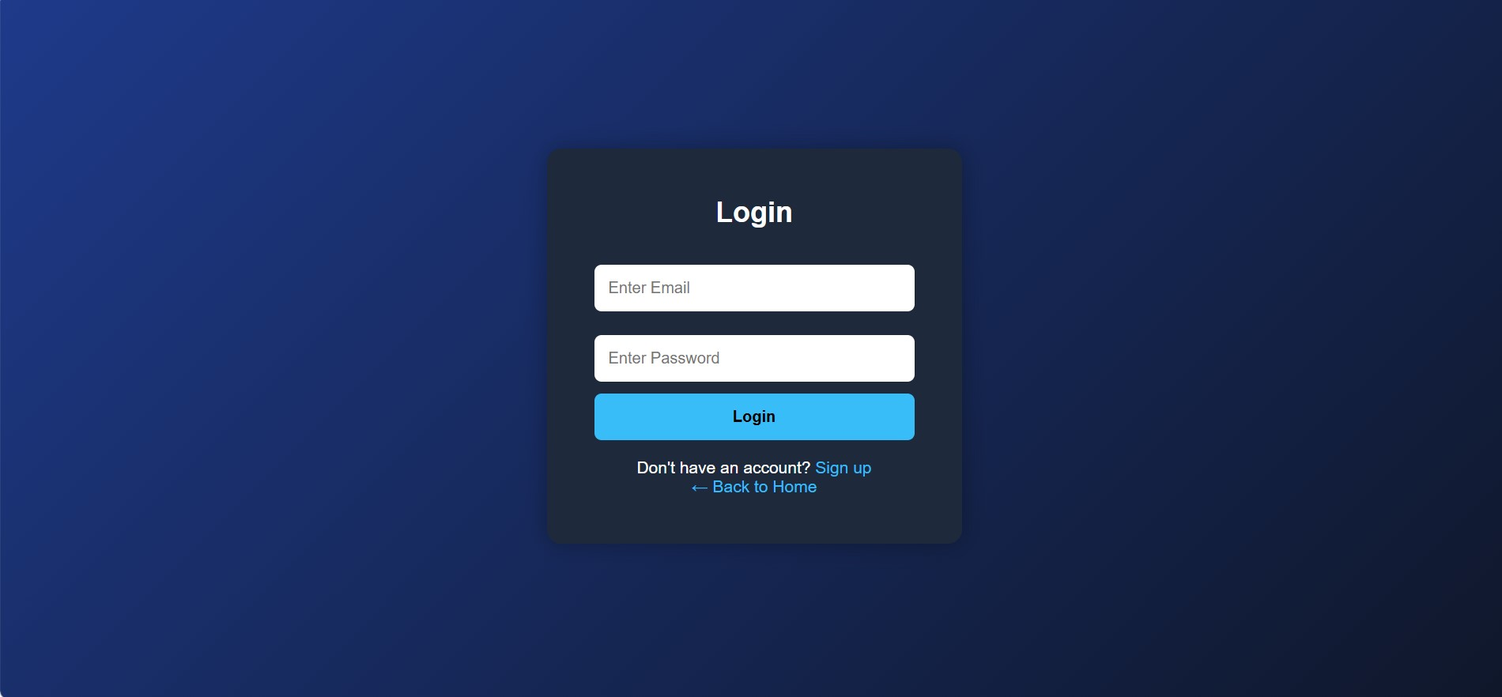
This is where users who have created an account on my page will log into their accounts in order to navigate on the lost or found page smoothly
Register/sign up page:

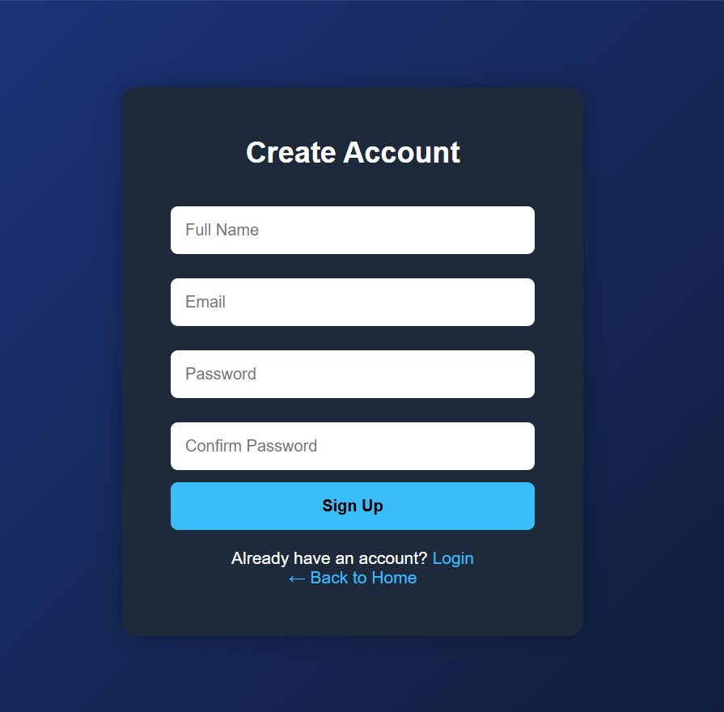
This is a page dedicated to new users who want to create an account on the lost and found hub

Report lost or found item page
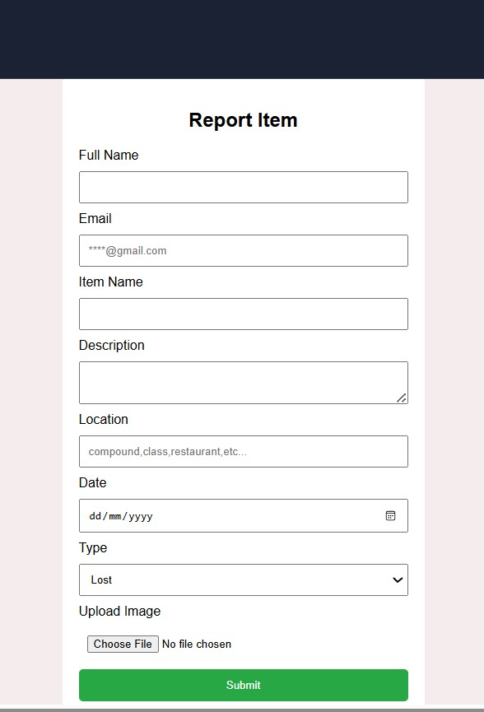
This is where the user will report either a lost object or a found object

Dashboard
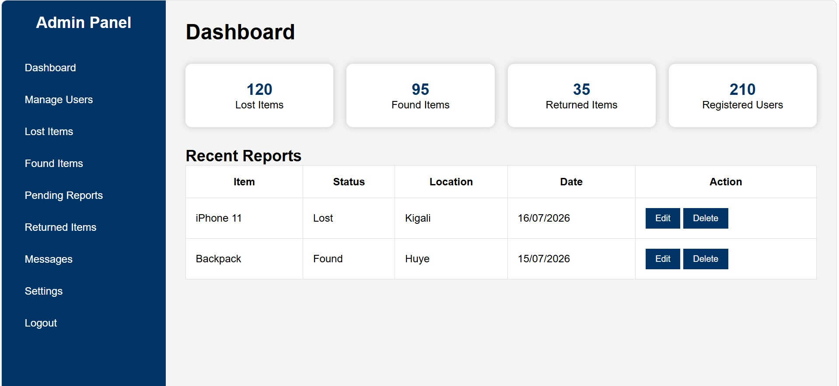
This is the administrator dashboard which will manage all the activities done on the webpage

Chapter 4: Conclusion and Recommendations
The project is 70% achieved since they are some other languages that I haven’t studied yet hence not being included in the web app so not yet completed as I want.
Recommendations:
To the Lecturer
- Encourage the use of version control systems like Git and GitHub throughout the project development process.
To the School
- Provide more time and resources for project development and testing.
To the Partners
- Adopt the system, assign an administrator, and maintain regular database backups.
To the Users
- Provide accurate information, upload clear images, and follow the user guidelines when using the system.
To the Beneficiaries
- Use the system to report lost and found items promptly and provide feedback for future improvements.
.

Appendix
GitHub repository link: gitihub link

